Lab 7

Driver (Ayush Shresth)

Scribe (Nachiketh Mamidi)

Part A:

2. In the main method, first the marker will reach the top wall, then it will turn right. Then “find window” method will be used. Since it has a wall on right side and dosent has a wall on the font it keeps moving forward to the left wall. Then it will turn left and again repeat the same process till it reaches the bottom wall. Then it will turn left again and stop beside the window.
3. If the window is on the bottom left corner, then the marker will go on an infinite loop and it will never find the window.
4. Since the method only checks if the right has a wall, we tried to keep the window in the bottom left and see how the main method works. Since it didn't work, we found the error.
5. To fix the error, add an if statement to check if right has a wall after the “Turn left” in “Find window method”. If it finds a window on its right then it returns, otherwise it moves forward.
6. When the window is to the right of the marker in the starting position it will just move forward and find it in the second trip. It solves the error if we add an if statement to check if there is a window on the right else it will continue the “find wal”l method

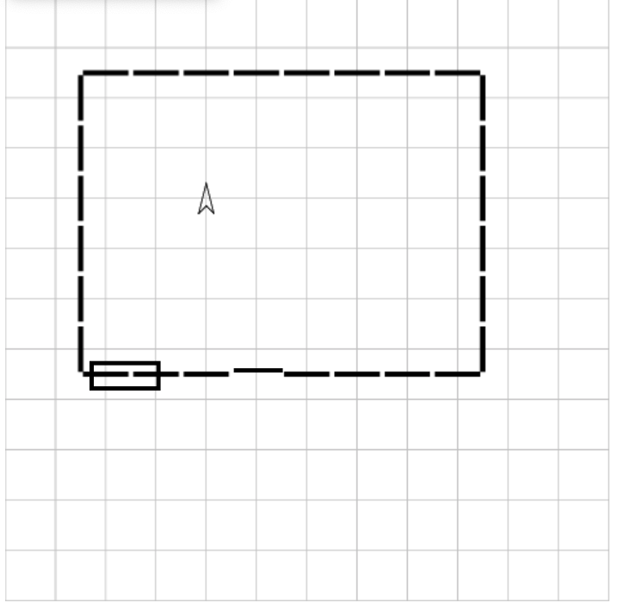

Part B:

1. It follows the method and finds the window.
2. We changed the call method’s x and y coordinate to (0, 3.5).

public void run()

{

makeRoom(8, 6, 0, 3.5);

carol.turnLeft();

goToWall();

carol.turnLeft();

findWindow();

}

1. The window appears on the left wall and the robot stops at the window.
2. We used run call and changed makeroom coordinates to (0.5, 6)

public void run()

{

makeRoom(8, 6, 0.5, 6);

carol.turnLeft();

goToWall();

carol.turnLeft();

findWindow();

}

1. The robot is on an infinite loop.

while (carol.rightHasWall())

{

if (carol.frontHasWallorWindow())

{

carol.turnLeft();

}

if(carol.rightHasWall())

carol.moveForward();

else

return;

}

1. It stops at the window. It has fixed the error.